

UNIT 4A CHURCH ROAD, HORLEY, SURREY, RH6 7EX
TEL: 01293 278455 FAX:01293 278466
E.MAIL profixcp@talktalkbusiness.net

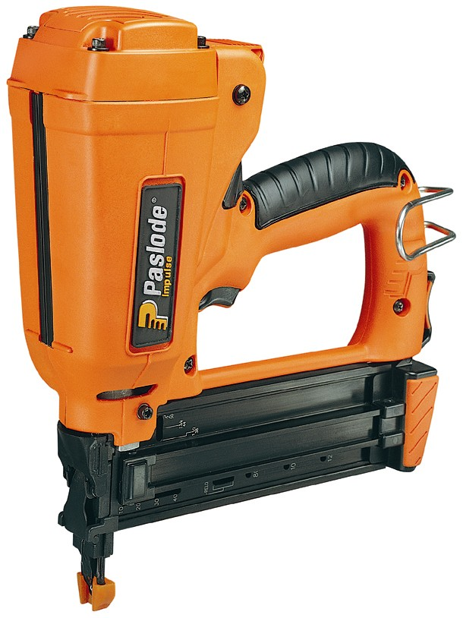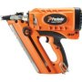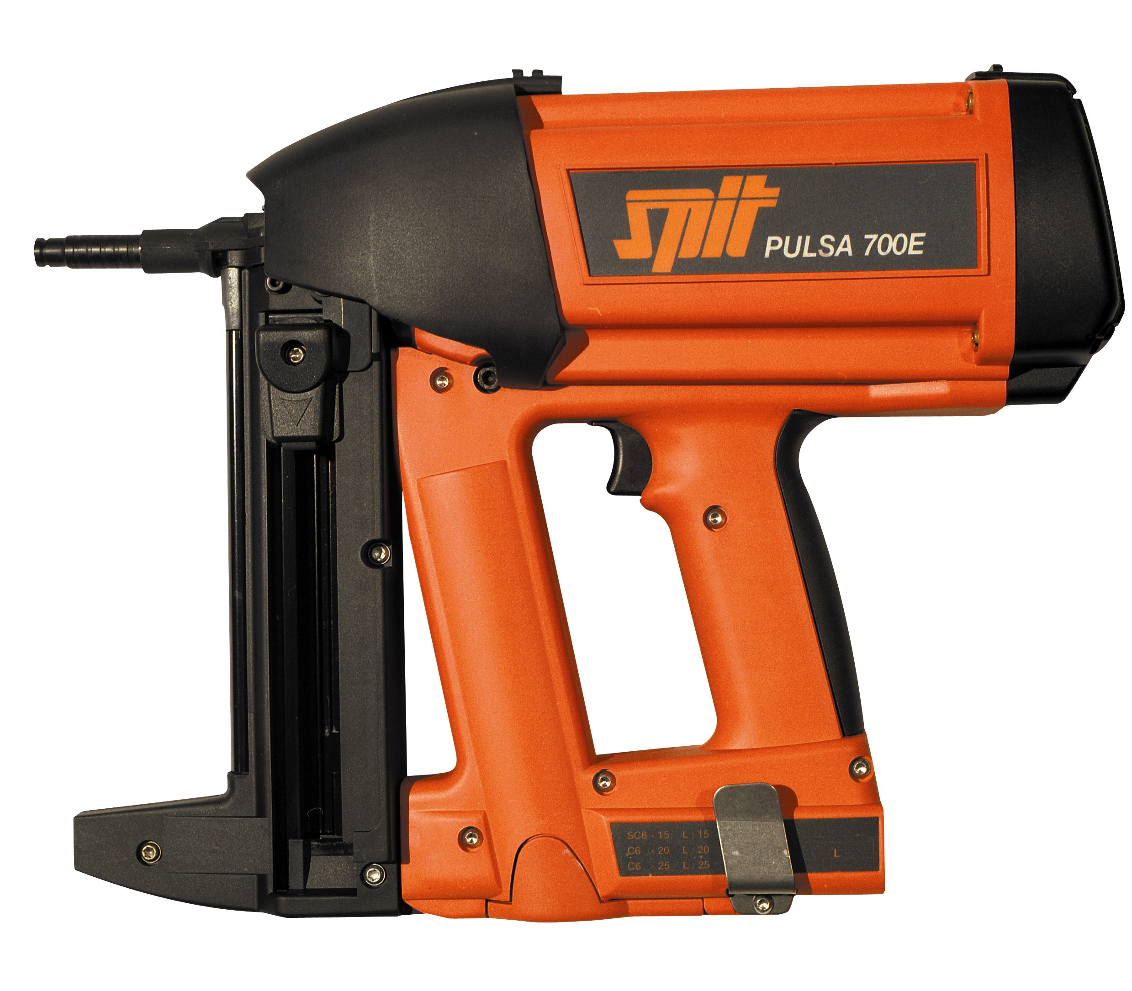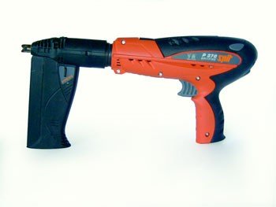

Tool Service Department:

Our aim is to offer a full service and repair facility for all Paslode/Pulsa and Generic Gas Nailers & Including Cartridge Tools.

Our standard service to all Gas Nailers Includes,

1. Complete Breakdown Of Tool & Deep Clean.
2. Inspect & Check All Electronics, Gas Delivery System, And Metal Moving Parts.
3. Rebuild Installing Replacement O-Rings, Stem Cell, Filters And Full Lubrication.
4. Test Fire Tool & Return.

Our initial aim is a 48hr turnaround on all gas nailers requiring a standard service.
For any tool requiring additional parts outside our standard service, we will always contact the owner to confirm items needed and cost’s attached prior to commencement of any repair.

Paslode IM350 1st Fix & IM250/IM65 2nd Fix

Standard Service Charge £49.95 +VAT.

Additional Accessories Available,

Spare Batteries To Suit IM350/IM250 £29.95 Each.

Spare Gas Cells To Suit IM350/IM250 £6.95 Each.

